**Rice, Elmer (1892-1967)**

Born Elmer Reizenstein in New York City on 28 September 1892, Elmer Rice’s career spanned nearly fifty years. He wrote over fifty plays, including collaborations with Dorothy Parker (*Close Harmony*, 1924), Philip Barry (*Cock Robin*, 1928), and Langston Hughes and Kurt Weill (the musical adaptation of *Street Scene*, 1947), and explored a variety of dramatic forms. His professional theatre debut came two years after graduation from New York Law School, with the enormously successfully *On Trial* (1914), a crime drama noted for its use of flashback. An anti-war play, *The Iron Cross* (1915), followed. Both works exemplify a career-long interest in inflecting the melodramatic form with new methods and in exploring the complexities of modern life. These inclinations are seen in *The Adding Machine* (1923) and *Street Scene* (1929). The former, a critique of the machine age, is a model of American expressionism; the latter advanced stage realism in the United States with a disorienting depiction of urban life. While these plays demonstrate an interest in new techniques, they are also rooted in melodrama and sought to promote liberal democratic social reform. *Street Scene* was awarded the 1929 Pulitzer Prize for Drama.

In the 1930s, Rice turned to dramatizing the Depression and the threat of fascism with *We, the People* (1933), *Judgment Day* (1934), and *Between Two Worlds* (1934). He served as New York regional director of the Federal Theatre Project, resigning when his Living Newspaper, *Ethiopia* (1936), was censored. Rice frequently directed his own and others’ plays, most notably Sherwood Anderson’s *Abe Lincoln in Illinois* (1938).

Following *Dream Girl* (1945), which merged realism with fantasy, Rice’s retreated from practical work in the theatre. Though occasionally seeking productions for his plays, notable contributions from this time were his collection of essays *The Living Theatre* (1959) and his autobiography *Minority Report* (1963). Along with Eugene O’Neill, Rice was responsible for bringing international attention to American drama in the first half of the twentieth century through his dedication to innovation and commitment to the social function of theatre.

# List of Works

Rice, Elmer. (1950) *Seven Plays*, New York: Viking.

------ (wr. 1915; pub. 1965) *The Iron Cross,* California: Proscenium Press.

------ (1929) *The Subway*, New York: Samuel French.

------ (1933) *We, the People*, New York: Coward-McCann.

------(1959) *The Living Theatre,* New York: Harper and Brothers.

------ (1963) *Minority Report*, New York: Simon and Schuster.

**References and Further Reading**

Durham, Frank. (1970) *Elmer Rice*, New York: Twayne Publishers.

Palmieri, Anthony F. R. (1980) *Elmer Rice: A Playwright’s Vision of America*, Cranbury, NJ: Associated University Presses.

Vanden Heuvel, Michael. (1996) *Elmer Rice: A Research and Production Sourcebook*, Westport: Greenwood Press.

**Jonathan Chambers, Bowling Green State University**

**Recommended Illustrations**

[listed in order of preference]

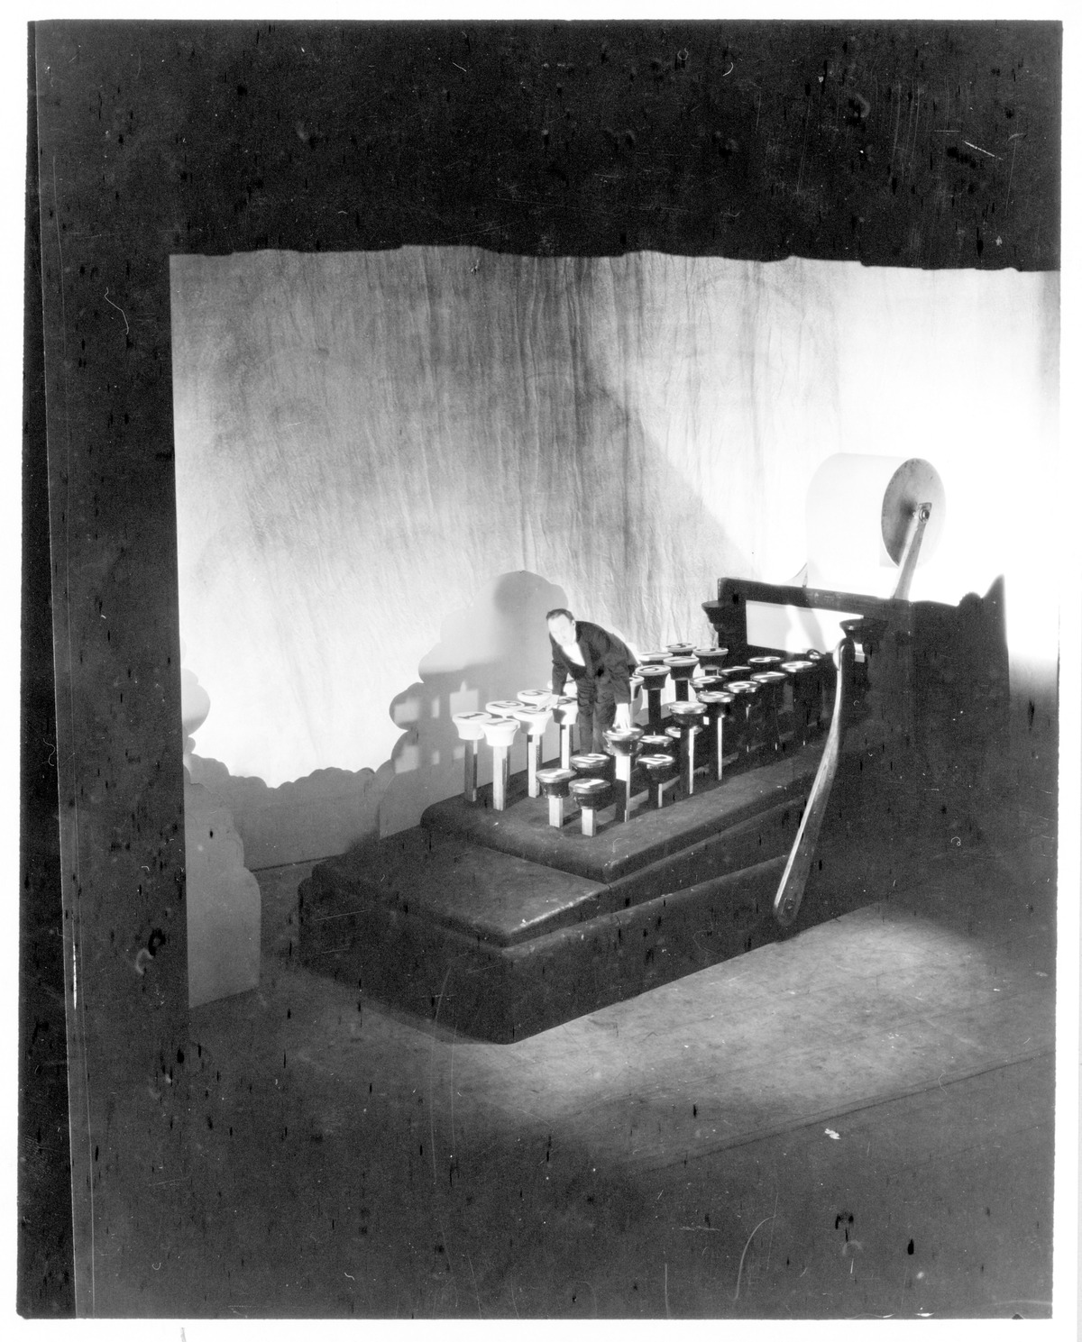

***The Adding Machine*, Theatre Guild, New York, 1923. Set design by Lee Simonson.**

[This image is included in the Samuel French edition of the play.It is also available at the Beinecke Rare Book and Manuscript Library, Yale University:

<http://brbl-dl.library.yale.edu/vufind/Record/3776985>]

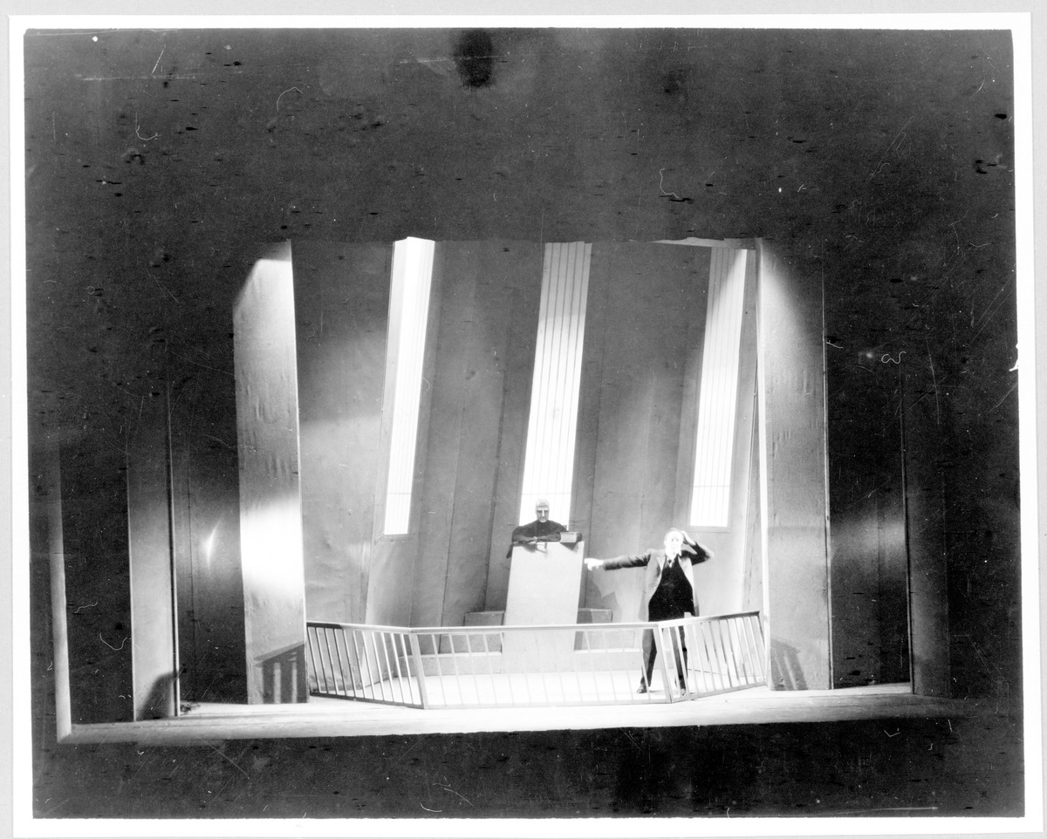

***The Adding Machine*, Theatre Guild, New York, 1923. Set design by Lee Simonson.**

[This image is included in the Samuel French edition of the play.It is also available at the Beinecke Rare Book and Manuscript Library, Yale University: http://brbl-dl.library.yale.edu/vufind/Record/3776984]



**Elmer Rice**

[Billy Rose Theatre Collection, New York Public Library Digital Gallery, Image ID: th-46643, available at: http://digitalgallery.nypl.org/nypldigital/dgkeysearchdetail.cfm?trg=1&strucID=1039473&imageID=th-46643&word=elmer%20rice&s=1&notword=&d=&c=&f=&k=1&lWord=&lField=&sScope=&sLevel=&sLabel=&sort=&total=7&num=0&imgs=20&pNum=&pos=1]